SZYFRATORZY – TESTS DOCUMENTATION

State by day: 22.03.2018r
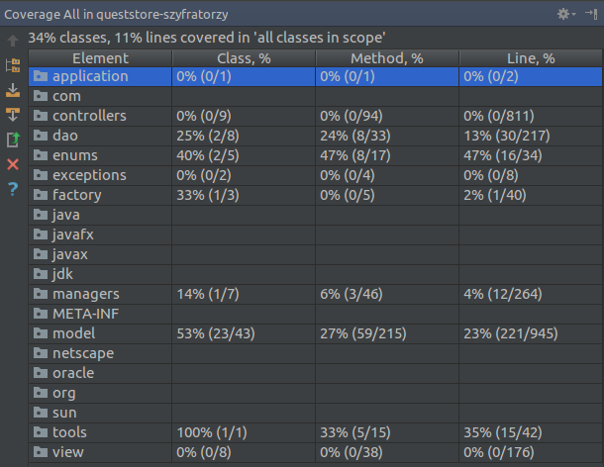
Tests created:
Classname : AdminDAOTest
- extractModel_shouldReturnProperParsedAdminModel
- saveModel_properOperationShouldReturnTrue
- saveModel_unproperSQLOperationShouldReturnFalse

Classname: AdminFactoryImplTest
- create_returnsProperlyCreatedAdminObject

Classname: ArtifactDAOTest
- extractModel_shouldReturnProperParsedArtifactModel
- saveModel_properOperationShouldReturnTrue

Classname: ArtifactFactoryImplTest
- create_returnsProperlyCreatedArtifactObject

Classname: ArtifactTest
- getPrice_ReturnsCorrectValue
- setPrice_changesArtifactPriceToNewValue
- artifactShouldNotHaveMinusValue
- shouldNotBeAbleToChangeToMinus

Classname: GroupDAOTest
- extractModel_returnsProperParsedGroupObject

Classname: StudentTest
- studentWalletShoudntBeOnMinus

Classname: TransactionTest
- constructor_createsProperTransactionObject
- constructor_transactionPriceIsSetToZeroWhenNegativeNumberPassed

Classname: UserTest
- getEmail_ShouldReturnProperlyConstructedEmailAdress
- constuctor_numbersInNameShouldThrowIllegalArgumentException
- constructor_numbersInSurnameShouldThrowIllegalArgumentException

Classname: DataToolTest
- isWhitespaceRemoved
- isStringShortened
- isStringBeingMultiplied
- isKeyRetrivedByValue
- isElementInArray

